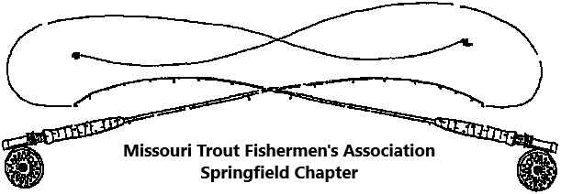
2024 Membership Application

I have an interest to improve the grand sport of Trout and Game fishing in Missouri and desire to give support to activities directed towards this end.

Make Check Payable to: MTFA-Springfield
Dues are not deductible for income tax purposes
Mail to:
Dennis Stead
4027 South Kentwood
Springfield, MO 65804

Date____________

Your Name:
Address:
City: State: Zip Code:
Home or cell Telephone:
e-mail address:

If applying for family membership, please list names spouse and children age 16 and under who should receive membership.
Spouse:
(1) _________________________________
(2) _________________________________
(3) _________________________________

Please circle or list a response to the following questions:
Are you an individual member of CFM paying dues directly to this organization?... Yes or No
Name a topic or program of interest. _____________________________________
What would you like more from the club? __________________________________
Newsletter preference: electronic e-mail? _____ or hard copy by U. S. mail ______

Annual Membership Dues

Family .............$20.00 Individual ...........$20.00 Contributing ................$25.00
Missouri Trout Fishermen’s Association - Springfield through calendar year 2024
-------------------------------------------------------------------------------------------------------------------
Use the following if receipt is needed for cash payment:

Received 2024 MTFA dues payment of $___________ from:____________________________ this date________________.

Signature of Treasurer or Membership Chairperson____________________________________

