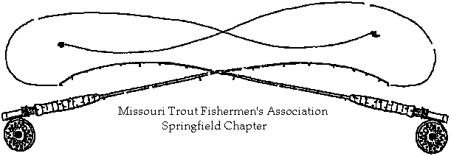
2017 Membership Application

I have an interest to improve the grand sport of Trout and Game fishing in Missouri and desire to give support to activities directed towards this end.

Date __________ | Make Check Payable to: | Missouri Trout Fishermen’s Association  Springfield Chapter
 | Mail to: | Robert Randall  892 Rose Hill Rd  Billings MO 65610
Name: «aaFirst_Name» «aaLast_Name»
Address: «address»
City: «City» State: «ST» Zip Code: «Zip»
Home Telephone: «phone»
e-mail: «email»

If applying for family membership, please list names spouse and children age 16 and under who should receive membership.
Spouse: «Spouse»
(1) _________________________________
(2) _________________________________
(3) _________________________________

Please circle or list a response to the following questions:

Are you an individual member of FFF paying dues directly to this organization?... Yes or No
Are you an individual member of CFM paying dues directly to this organization?... Yes or No
Name a topic or program of interest. _____________________________________
What would you like more from the club? __________________________________
Do you wish to receive newsletter via electronic e-mail?... Yes or No
Do you wish to receive a hard copy newsletter via U. S. mail?... Yes or No

Annual Membership Dues

Family .............$15.00 Individual ...........$15.00 Contributing ................$25.00

.............................................................................................................................................................
Name:
Received from ___________________ Date _____________ Amount $____________

Missouri Trout Fishermen’s Association - Springfield Chapter dues for calendar year 2017

