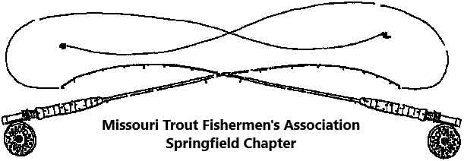
2023 Membership Application

I have an interest to improve the grand sport of Trout and Game fishing in Missouri and desire to give support to activities directed towards this end.

Make Check Payable to: MTFA-Springfield
Dues are not deductible for income tax purposes

You can complete this form digitally on your computer.

After completion, print and mail along with your check to:
Bob Randall
2239 W. Buena Vista St.
Springfield, MO 65810

Date: Click or tap here to enter text.

Your Name: Click or tap here to enter text.
Address: Click or tap here to enter text.
City: Click or tap here to enter text. State and Zip Code: Click or tap here to enter text.
Home or cell Telephone: Click or tap here to enter text.
e-mail address: Click or tap here to enter text.

If applying for family membership, please list names spouse and children age 16 and under who should receive membership.
Spouse: Click or tap here to enter text.
Children:
(1) Click or tap here to enter text.
(2)Click or tap here to enter text.
(3)Click or tap here to enter text.
Please click box or list a response to the following questions:
Are you an individual member of CFM paying dues directly to this organization?... ☐Yes ☐No
Name a topic or program of interest. Click or tap here to enter text.
What would you like more from the club? Click or tap here to enter text.
Newsletter preference: electronic e-mail? ☐ or hard copy by U. S. mail? ☐

Annual Membership Dues Click on one box

☐Family...$20.00 ☐Individual ...$20.00 ☐Contributing...$25.00
Missouri Trout Fishermen’s Association - Springfield through calendar year 2023

