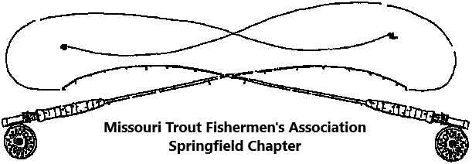
2021 Membership Application

I have an interest to improve the grand sport of Trout and Game fishing in Missouri and desire to give support to activities directed towards this end.

Make Check Payable to: MTFA-Springfield
Dues are not deductible for income tax purposes
Mail to:
Bob Randall
2239 W. Buena Vista St.
Springfield, MO 65810

Date____________

Your Name:
Address:
City: State: Zip Code:
Home or cell Telephone:
e-mail address:

If applying for family membership, please list names spouse and children age 16 and under who should receive membership.
Spouse:
(1) _________________________________
(2) _________________________________
(3) _________________________________

Please circle or list a response to the following questions:
Are you an individual member of FFF paying dues directly to this organization?... Yes or No
Are you an individual member of CFM paying dues directly to this organization?... Yes or No
Name a topic or program of interest. _____________________________________
What would you like more from the club? __________________________________
Newsletter preference: electronic e-mail? _____ or hard copy by U. S. mail ______

Annual Membership Dues

Family .............$15.00 Individual ...........$15.00 Contributing ................$25.00
Missouri Trout Fishermen’s Association - Springfield through calendar year 2021
-------------------------------------------------------------------------------------------------------------------
Use the following if receipt is needed for cash payment:

Received 2021 MTFA dues payment of $___________from:____________________________ this date________________.

Signature of Treasurer or Membership Chairperson____________________________________

